Resume
Seema Bharti
Cell: +91 7991137491, 7739010282
Email: seemabharti2007@rediffmail.com,
seemabhartiomk@gmail.com

Career Objective:

To achieve a responsible, challenging and equally rewarding position in teaching Computer Science.

Professional Experience:

- Presently working in Open Minds-A Birla School Kankarbagh, Jaganpura(2014- till date) as a ICT (HOD) and Activity Coordinator
- 1 year teaching experience in Kendriya Vidyalaya , Danapur cantt as PGT Computer Science (2013-2014)
- 3 years teaching experience in Krishna Niketan +2 Girls School as PGT Computer Science (2010-2013)
- 1 year experience in B.D.College , Mithapur, teaching B.C.A. students (2009-2010)

Education Profile:

Degree | Board/University | School/College | Year of Passing | % of marks obtained

Professional:
MCA | Magadh University, Patna | J.D.Womens College | 2009 | 79%
BCA | Magadh University, Patna | J.D.Womens College | 2004 | 65 %
Academic:
HSC | B.I.E.C | J.D.Womens College | 2000 | 62%
SSC | C.B.S.E. | Patna Central School | 1998 | 53%

Other Certifications:

- Doeacc ‘o’ level completed in 2004 with grade ‘B’

Skill Set:

Operating Systems | Windows , Unix
Language Known | C, C++, Java netbeans
Database | Oracle, SQL Server , MySQL

PERSONAL DETAILS
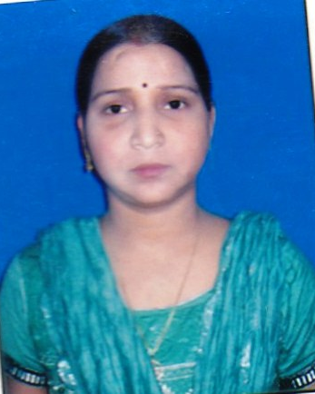
Date of Birth : 15th Jan. 1984
Fathers Name : Mr. Jagdish Prasad
Status : Married
Residential Address : c/o vishu Kumar
Mithapur, B.Area.
K.P. Sarkar road
: Patna, Bihar
: Pin-800001

Language Skills : Hindi, English

Declaration
I hereby declare that the information furnished above is true to the best of my knowledge.

Place : Patna [Bihar] Seema Bharti
Signature

